**Project Development Phase**

**Performance Test**

|  |  |
| --- | --- |
| Date | 20 October 2023 |
| Team ID | NM2023TMID02554 |
| Project Name | Project – Unleashing the Potential of our Youth – A Student Performance Analysis. |

**Model Performance Testing:**

Project team shall fill the following information in the performance testing template.

|  |  |  |
| --- | --- | --- |
| **S.No.** | **Parameter** | **Screenshot / Values** |
|  | Dashboard design | No of Visualizations / Graphs – 12 visualizations and 3 tabs  <https://drive.google.com/file/d/1cPCWp7qCH5_u_oBxZqQfn9mYljwLCfNa/view?usp=share_link> |
|  | Data Responsiveness | yes |
| 3. | Utilization of Data Filters | 4 |
| 4. | Effective User Story | No of Scene Added – 8  <https://drive.google.com/file/d/1CbrWAjcc-PJz-my7mfVYjYJGjpP7ErHA/view?usp=share_link> |
| 5. | Descriptive Reports | No of Visualizations / Graphs – 4  <https://drive.google.com/file/d/1FZe8KCnMfUwjV5sWiSpZPOImtnEWJjok/view?usp=share_link> |

**DASHBOARD:**

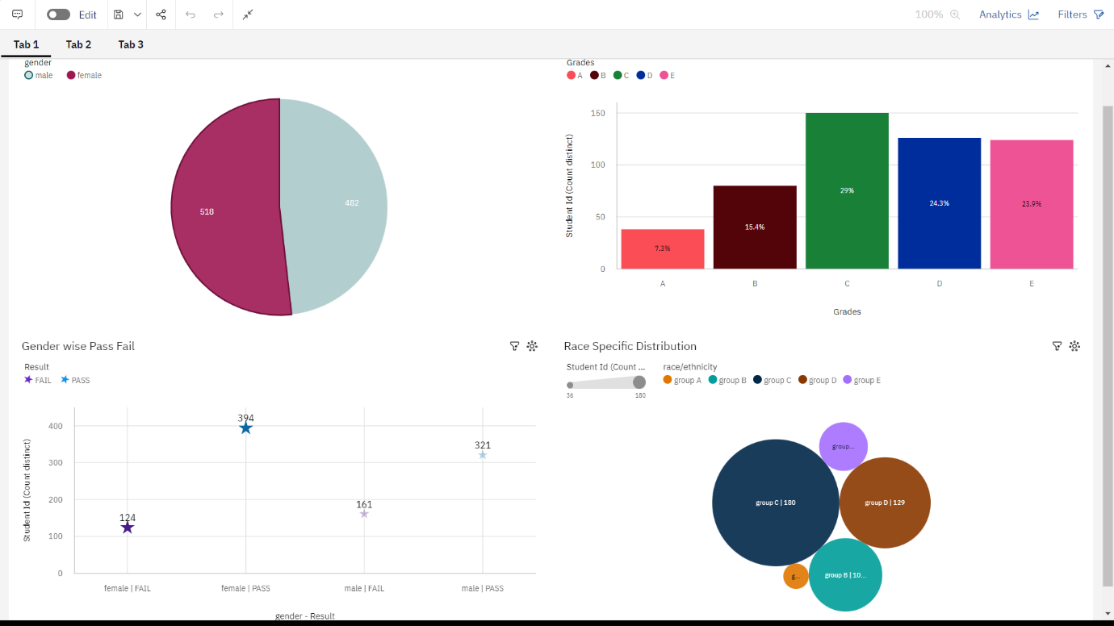

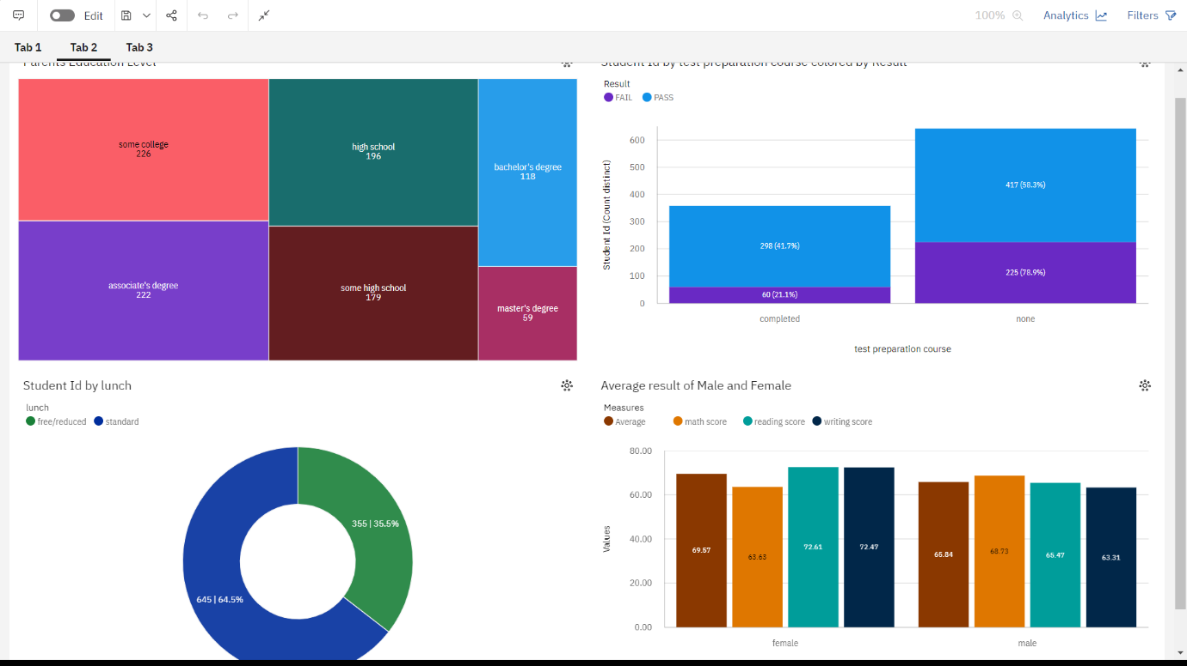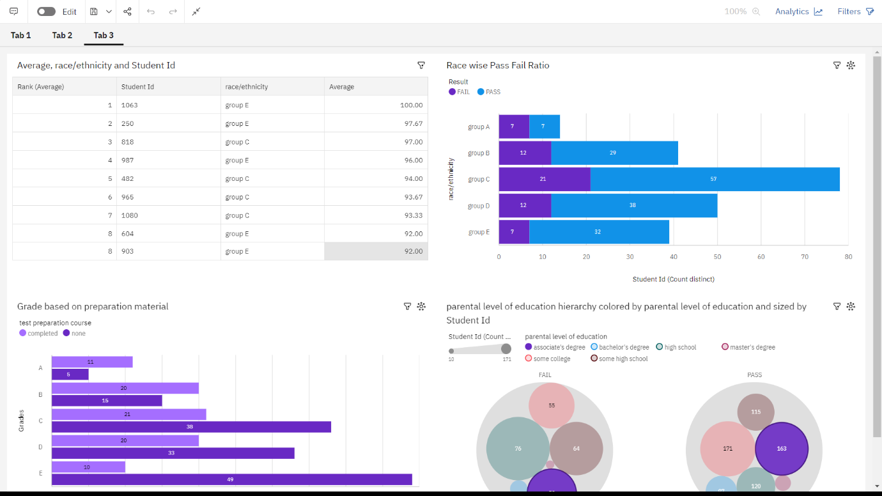

**STORY:**

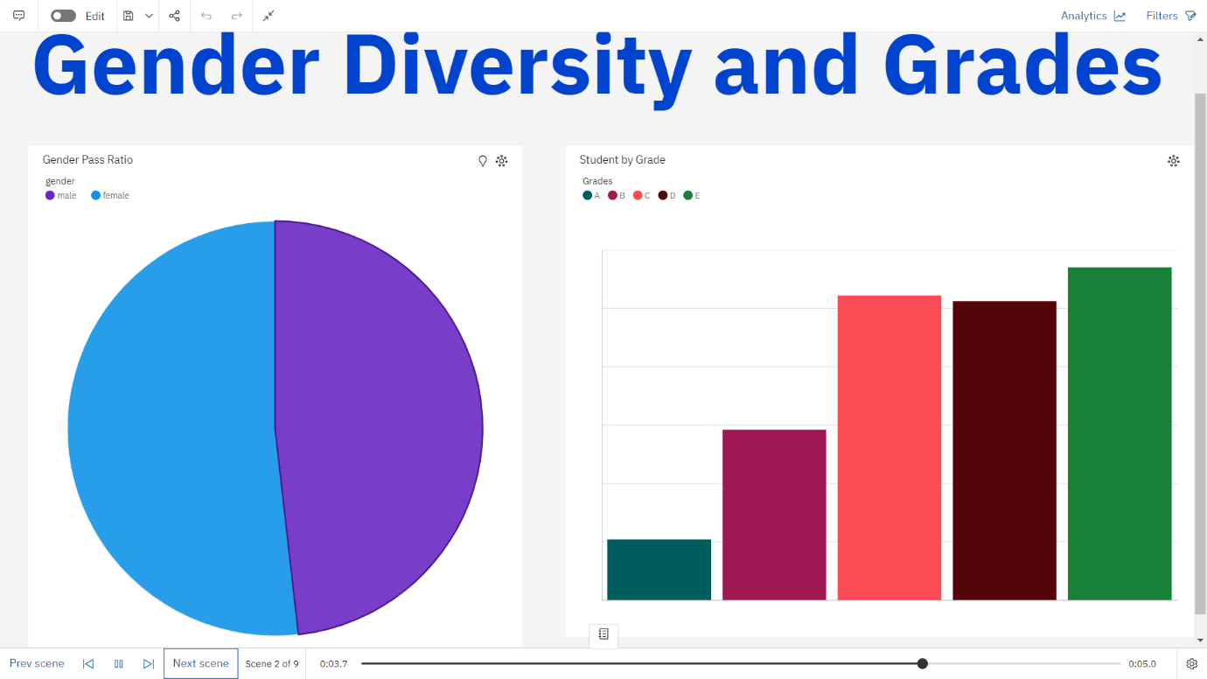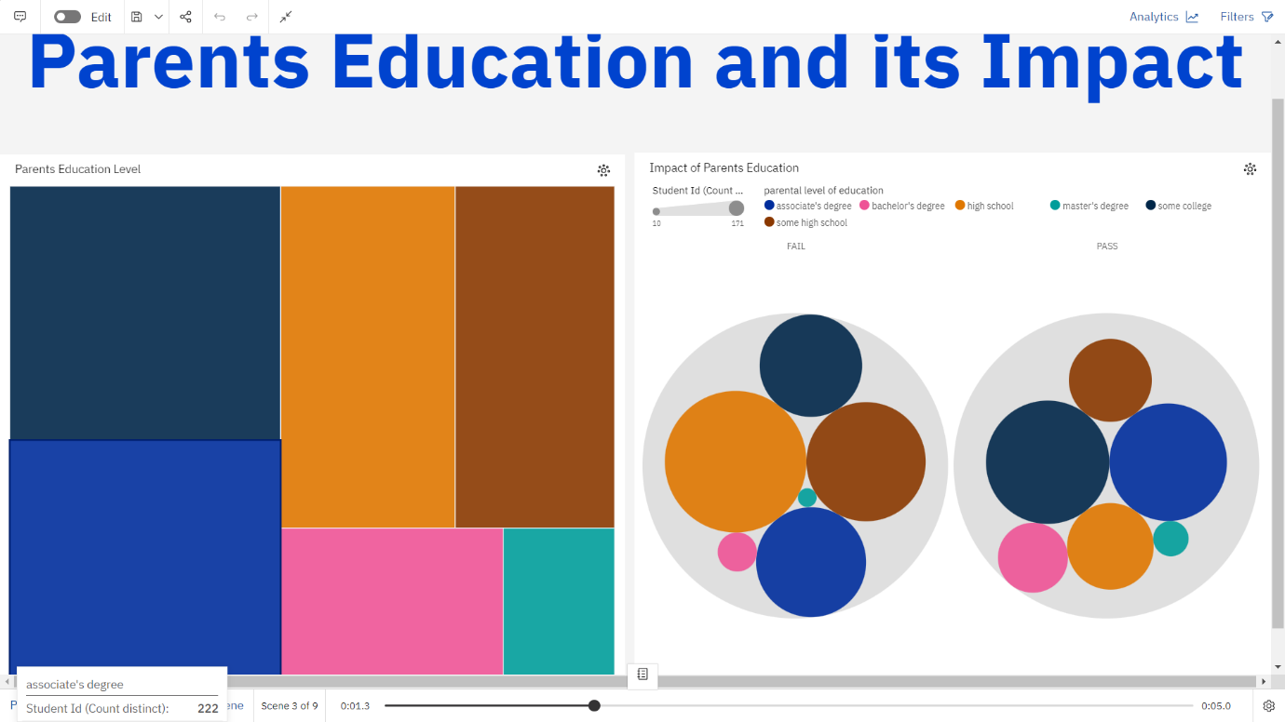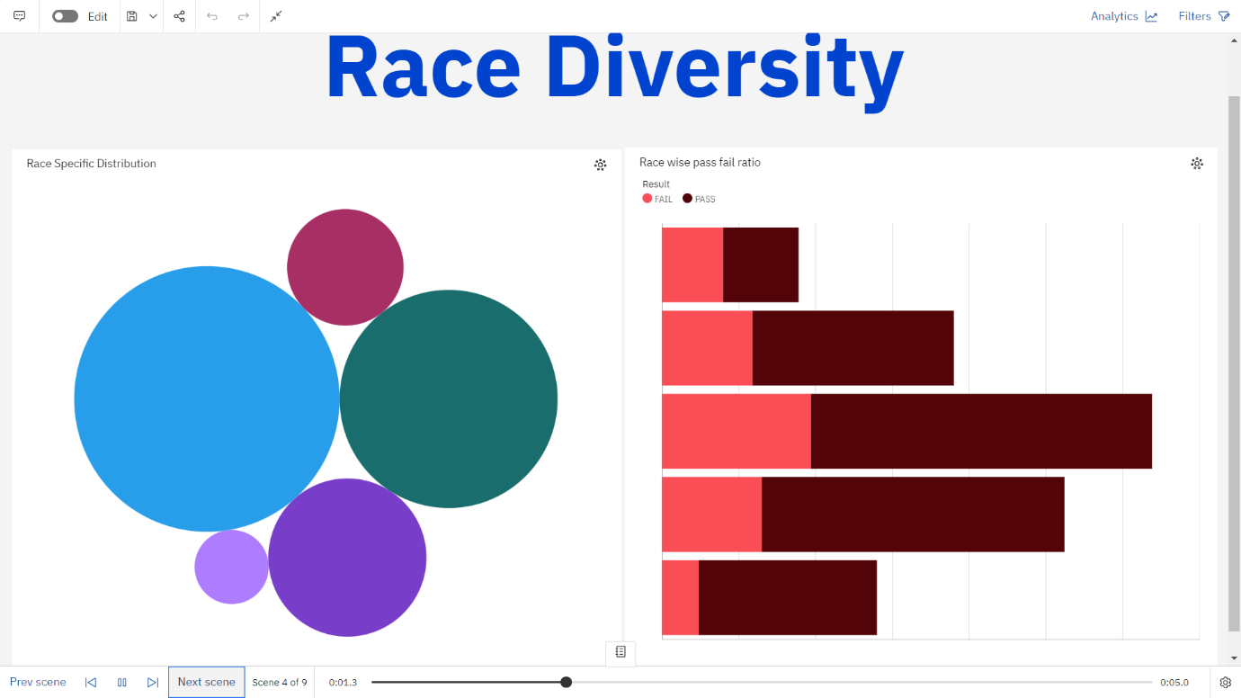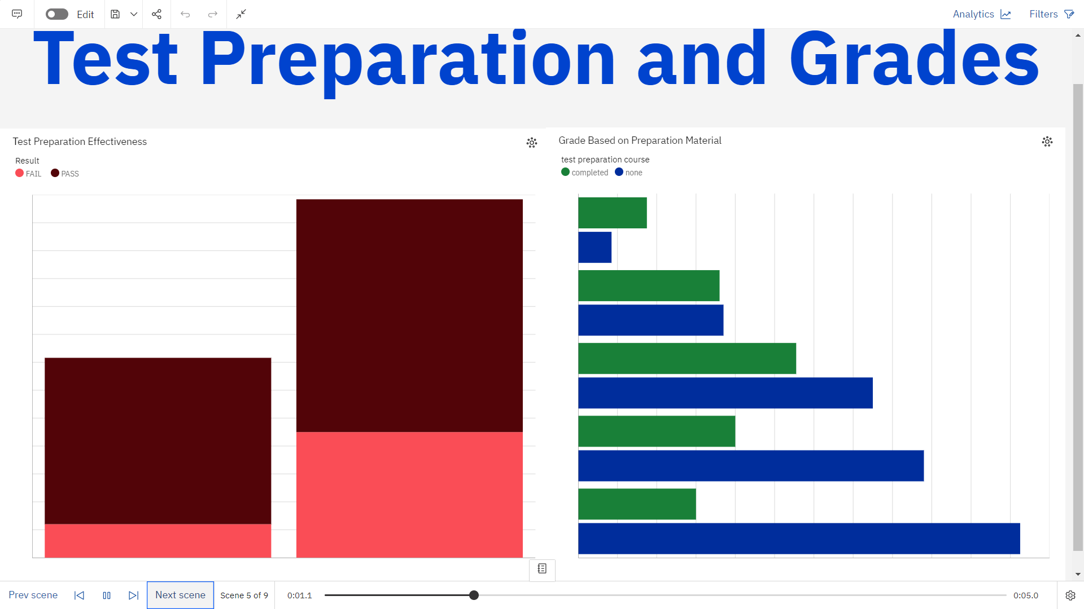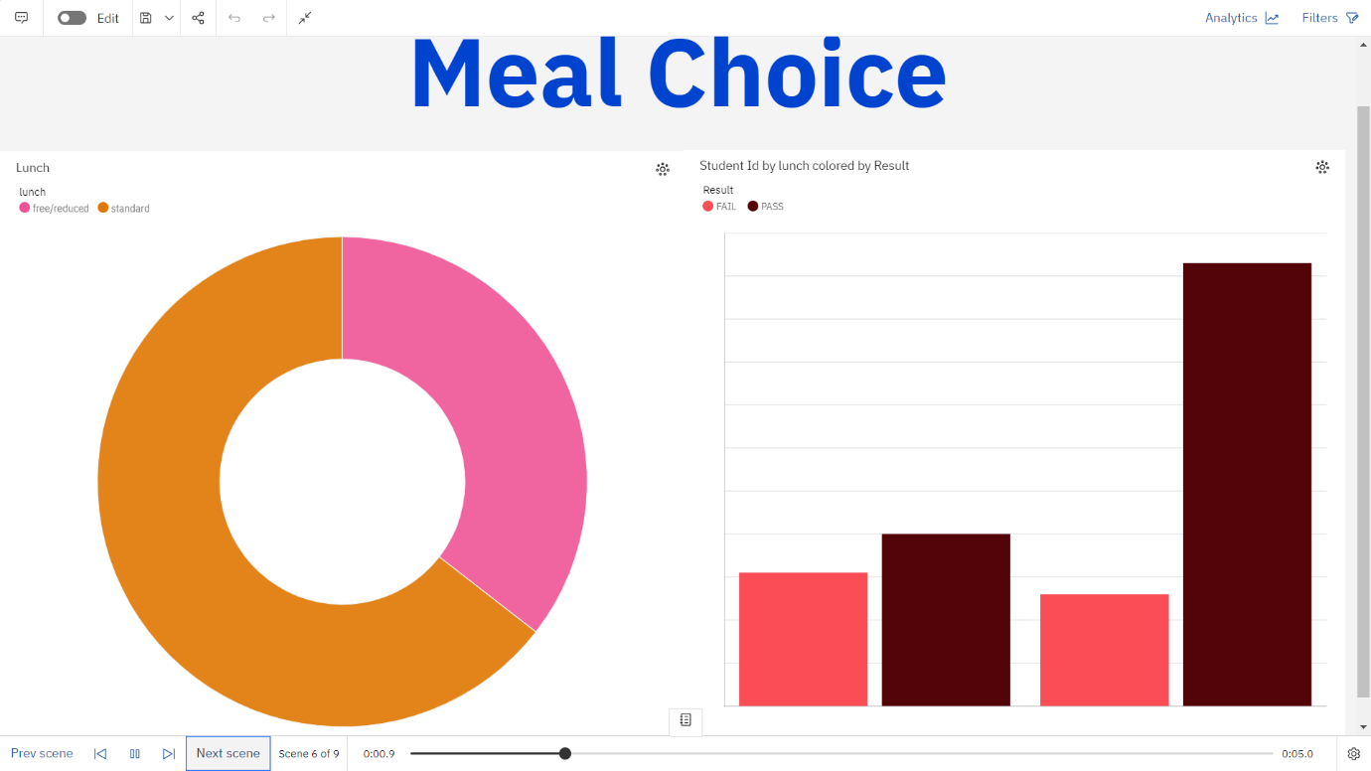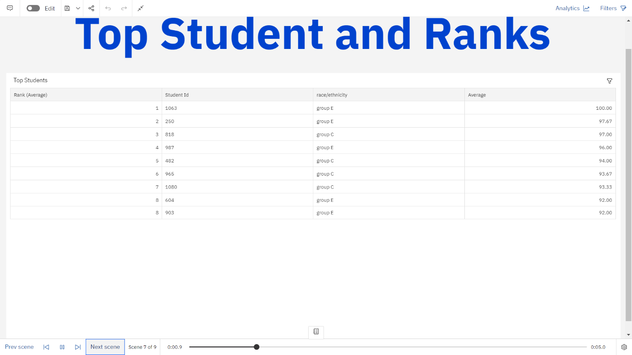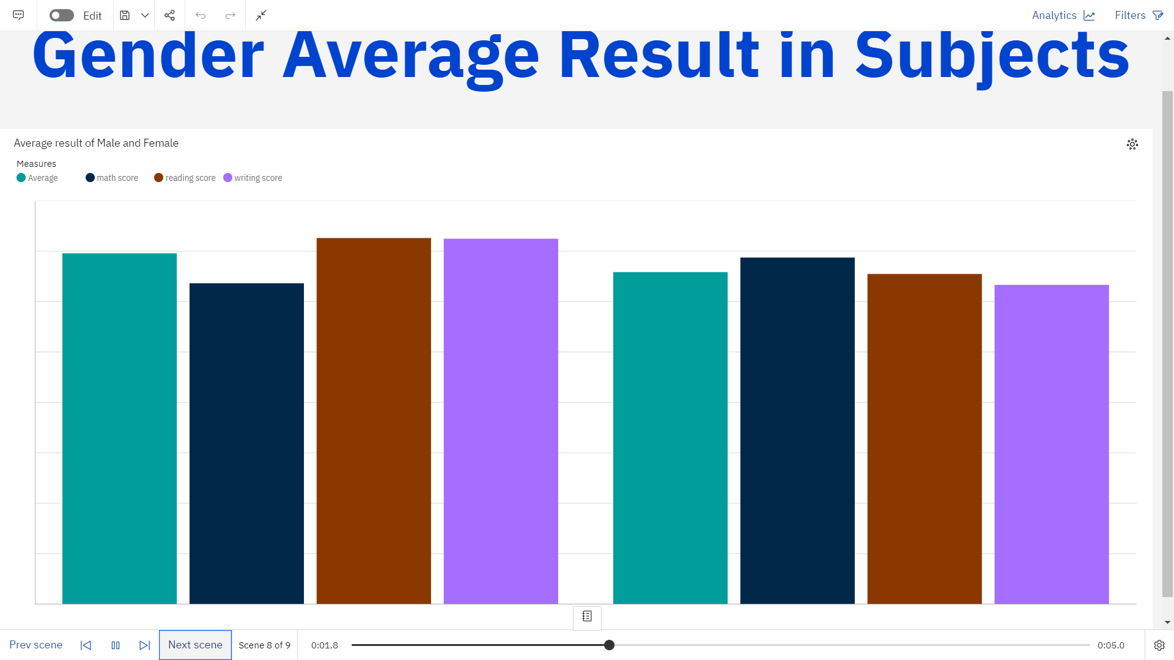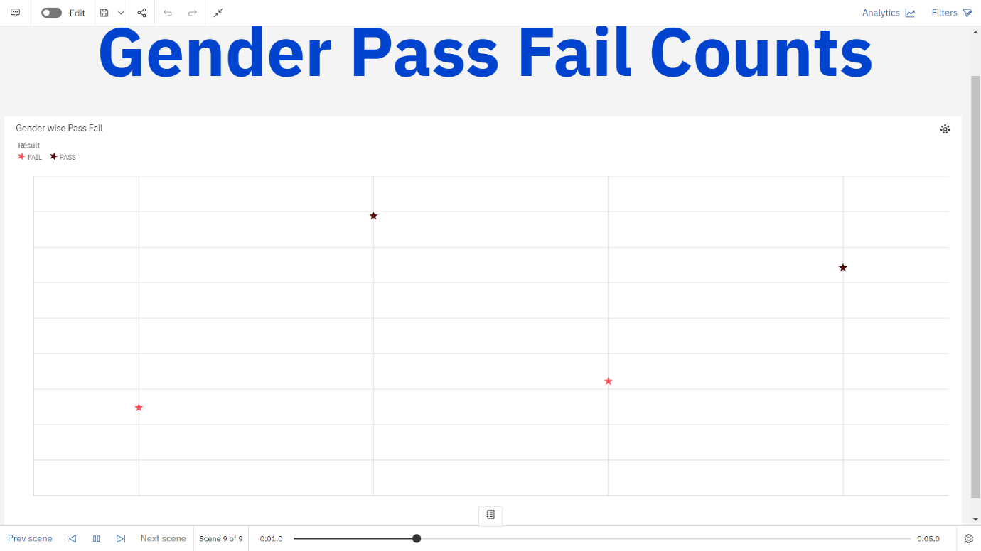

**REPORT:**

